**08/12/2022**  
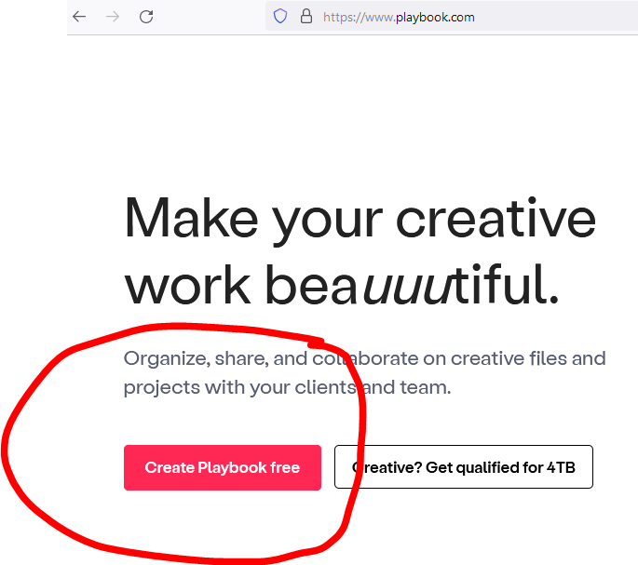

Please choose a color like this as I mentioned on hussle which was like this.

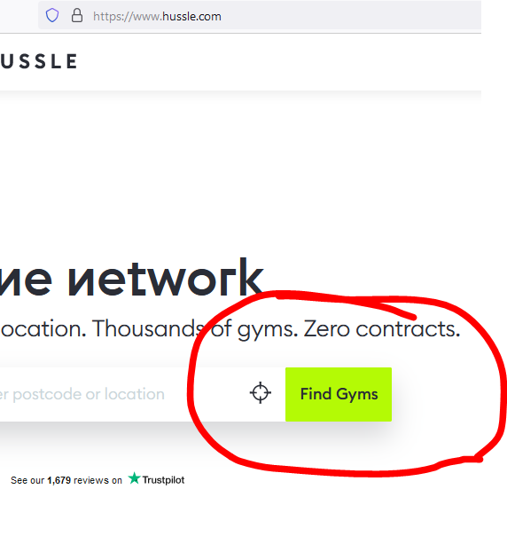

**You can chose Cobalt color or Pink color, not sure, Something chatkila and stand out. Front end designer might suggest something.**

**Fonts are very basic, I gave hussle and few other website as reference. Please use soft and sharp bold font.   
Please look at the design hussle used, please keep backround white and grey with dark grey fonts plus some color here and there to keep website stand out, AS THE HUSSLE WEBSITE.**

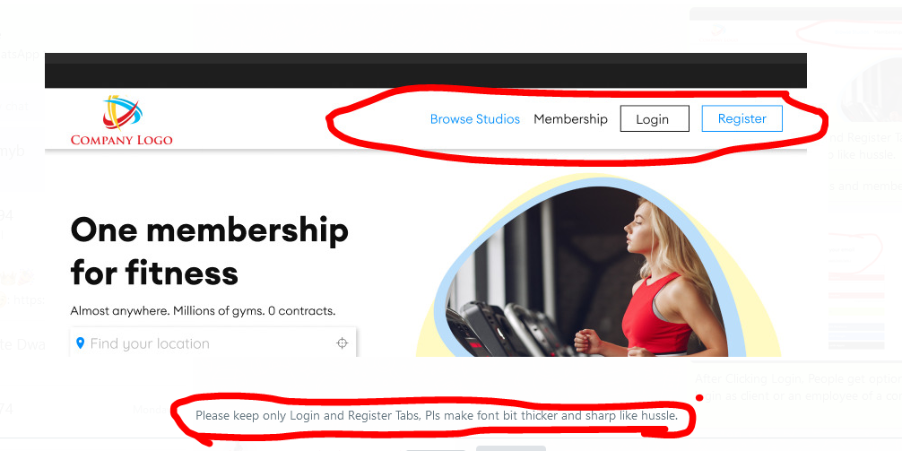

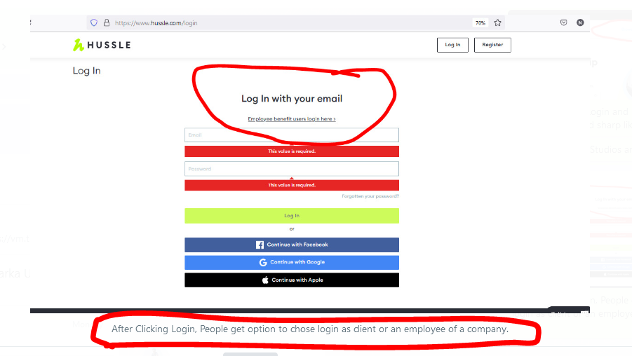

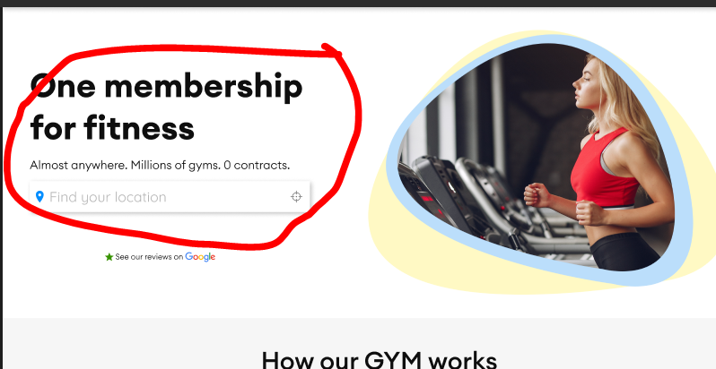

**Thousands of Sports, Fitness, Gym Session or Adventure.  
Zero Contract. Unlimited Activites.**

Instead the photo of a girl on right please put few photos of kids football session, Gym Kickboxing session, Crossfit and Paintball Adventure. Please see the referenced websites.  
  
hussle.com, https://www.getfitso.com/, https://classpass.com/, https://geronigo.com/, https://gympass.com/, https://www.fitternity.com/, https://fitpass.co.in/,

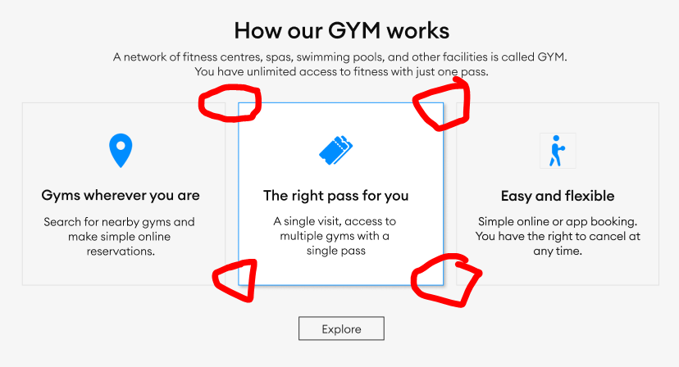

All boxes edges should be curved.  
Background little darker like Hussle.

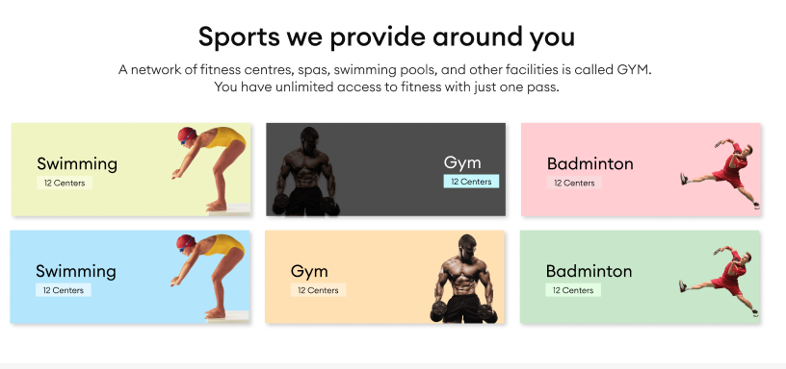

First Kid playing football, Second Gym Boxing Session, Third women cycle session in gym,  
Fourth Adventure session like Painball from geronigo.com website, Fifth Crossfit pic fitpass.co.in, Sixth, Swimming session.

***14Th Dec 2022***

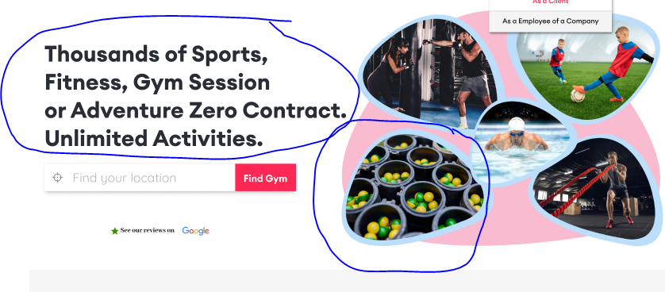

**Any Activity. Sports, Fitness, Gym Session or Adventure.**Zero Contract. Unlimited Activites.  
  
  
Please put like this, you put large fonts.

What are those balls in the buckets.   
Please put Paintball Activity like this.  
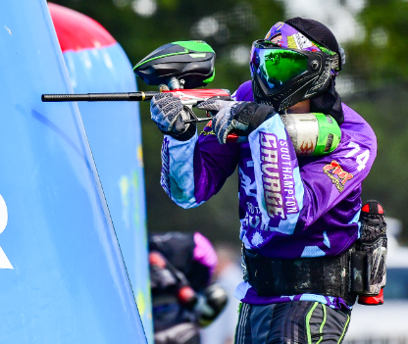

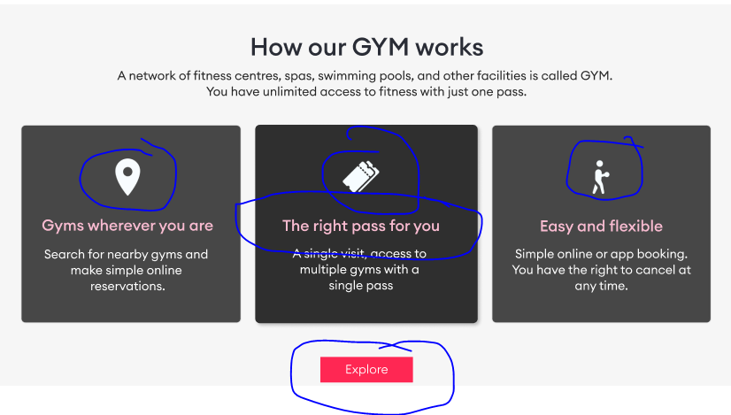  
The right pass for you, Gyms where you are color does not match Explore Color. The logos above are complete copy of hussle, pls change them.

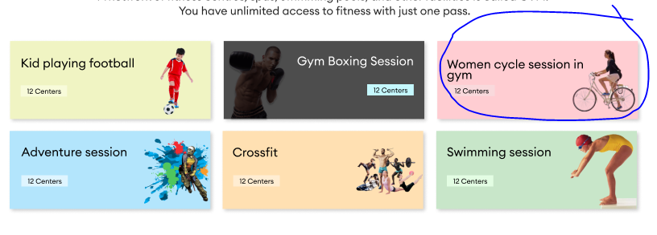  
There is no gym in world where women ride this bicycle. Please change it to similar like this.  
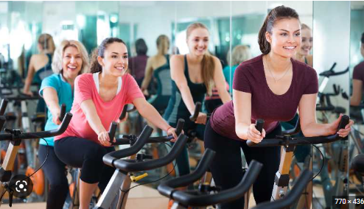

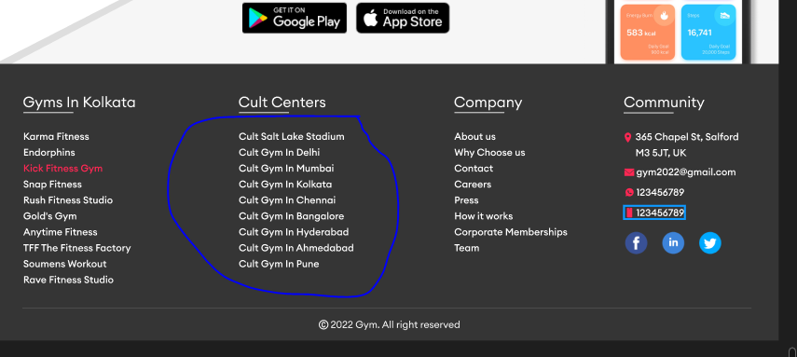  
Because there will be 1 website for UK and one website for India.  
Please put UK cities like this.  
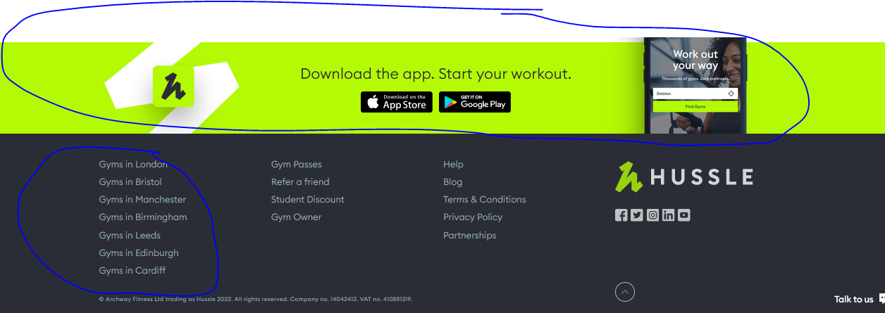  
Design like this poppat color, Chatkila Pink for us and Cobalt should be used more on website.  
______________________________________

15 Dec 2022  
  
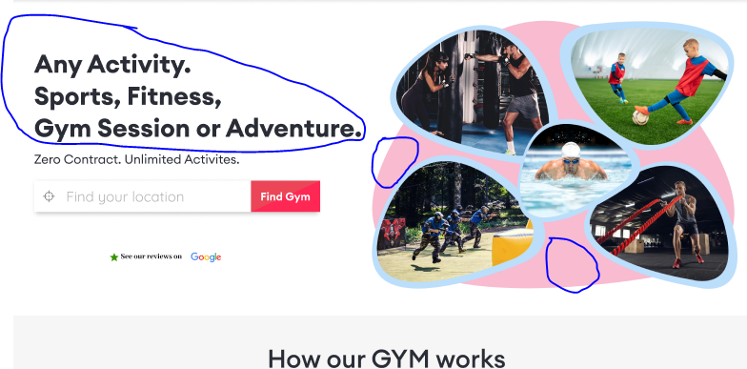  
Seems fine to me, however few things can be changed here like **Any Activity. Sports, Fitness, Gym Session or Adventure. Font can be bit smaller, I have to see how it looks. The pink color behind the these 5 pics looks bit odd, So I have to see how it looks with grey in back.   
Overall It seems ok to proceed to next step on the basis that 90% of the content to be changed there. Also Many pics are copied from hussle and indeed those need changing too. Final touchup will be required at the later stage, however it seems fine to proceed to next step.**